**Maven**: Maven is a java-based build management tool.

**Java program life cycle**: it is generating output from source code, but prior to that we need to install java on system.

ubuntu@ip-172-31-20-224:~$ which java /usr/bin/java

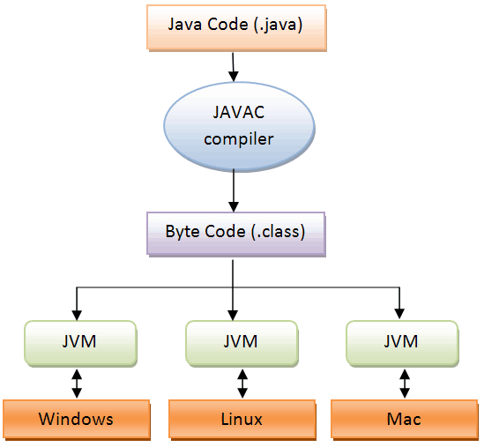

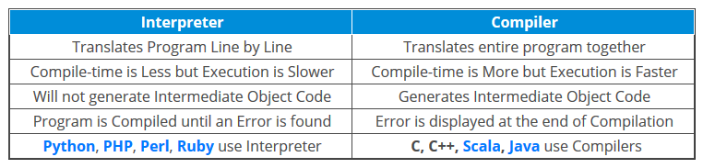

Casestudy: what if we need to execute code of 1000 java file(s). Ans: Go for Maven.

Java program life cycle: java-> compile-> bytecode -> java o/p

Build tool: Ant, Maven.

Maven: compile, test, package and dependencies.

Dependencies: May be your application using third party software such as messaging. We can download those libraries by dependency.

### What is a POM? A Project Object Model or POM is the fundamental unit of work in Maven. It is an XML file that contains information about the project and configuration details used by Maven to build the project. It contains default values for most projects. Examples for this is the build directory, which is target; the source directory, which is src/main/java; the test source directory, which is src/test/java; and so on. When executing a task or goal, Maven looks for the POM in the current directory. It reads the POM, gets the needed configuration information, then executes the goal.

### mvn -v: maven version listing.

### File Structure:

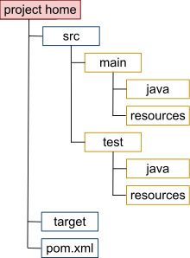

Dependency: <https://mvnrepository.com/artifact/com.google.guava/guava-gwt/28.1-jre>

Maven for dependency management.

**spring/hibernate- just a dependency.**

maven popular because of dependency management.

Maven is a build tool. it also can manage dependency.

mvn clean package clean build: remove target folder and restart build

mvn test: for execute unit testing

mvn package: for creating jar/war/EAR

mvn compile: for compiling code

mvn -v: for checking version